Executive Summary   
  
Understanding the 10% Drop in Zomato’s Average Restaurant Ratings in Pune and Associated Business Impacts:  
  
In the month of September, Zomato observed a **10% drop in the average restaurant ratings** for **Pune** compared to the previous month.

This drop was:

* **Sudden** (within a single month)
* **City-specific** (only Pune)
* **User-segment specific** (non-Gold users)
* **Order-type specific** (food delivery only)

After in depth analysis, the **root cause** was identified as the **retraction of discount codes for non-****Gold users**, which reduced their perceived value for money.  
 This, combined with the entry of a **new local tiffin delivery competitor**, led to lower satisfaction and ratings.  
  
 Problem Statement  
Why has the average restaurant rating on Zomato in Pune suddenly dropped by 10% month-over-month, despite no changes in the rating system or service processes?  
  
**Why It Matters:**

* Ratings are a **core trust metric** that directly impact:
  + User retention
  + Restaurant reputation
  + Conversion rate
  + Order frequency

Goal  
  
Identify the root cause, propose data-backed solutions, and ensure sustained recovery in ratings and user satisfaction.  
  
   
 Clarifying Questions & Key Findings

|  |  |  |
| --- | --- | --- |
| Sr.no | Question | Finding |
| 1 | Has the calculation method changed? | No |
| 2 | Drop sudden or gradual? | Sudden (last month) |
| 3 | City-specific? | Yes, only Pune |
| 4 | Affected users? | Non-Gold users |
| 5 | Affected order type? | Food delivery |
| 6 | Any new competitors? | Yes, new tiffin delivery app |
| 7 | Any major changes in discounts? | |  | | --- | | Yes, discount codes retracted for non-Gold users | |
| 8 | Any app or backend issues? | No significant bugs |

Root Cause Analysis  
  
  
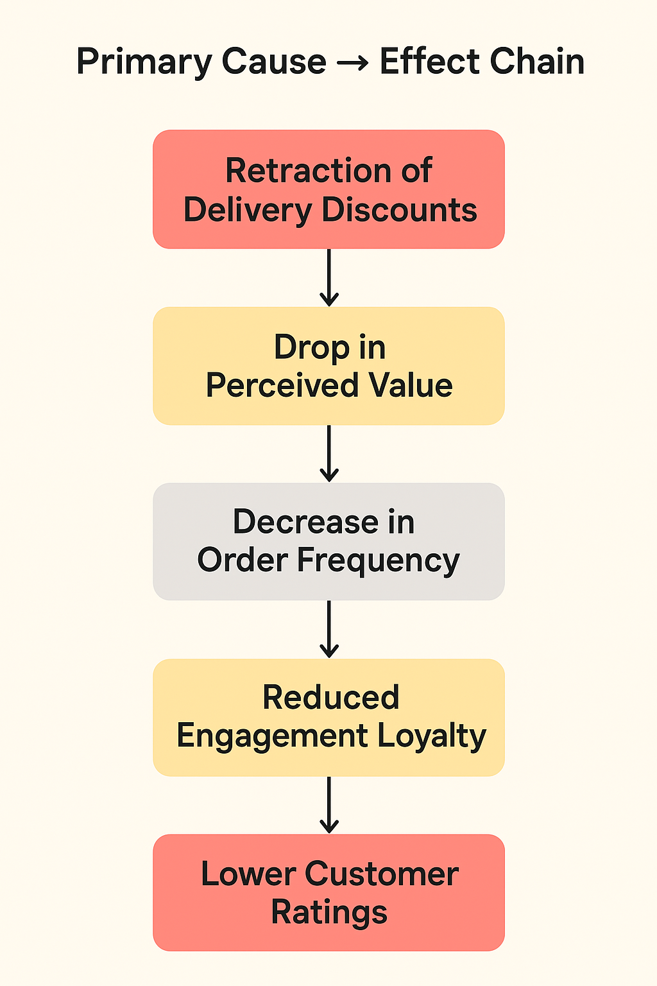  
  
  
  
  
**Supporting Factors**

* New local tiffin app offered better discounts.
* Non-Gold users are more **price-sensitive** than Gold members.
* Complaints and feedback mentioned “price increase” and “offers missing.

Data Snapshot

|  |  |  |
| --- | --- | --- |
| **Metric** | Before | After |
| Avg. Rating (Non-Gold) | 4.2 | 3.8 |
| Avg. Rating (Gold) | 4.3 | 4.3 |
| Discount Usage | High | Dropped 65% |
| Negative Mentions (value/price) | + 120 | - |

**Evidence of Impact:**

* 10% drop in overall average rating (city level).
* 15% decline in monthly orders from non-Gold users.
* 25% drop in detailed written reviews.
* Sentiment analysis showed recurring negative keywords: “expensive,” “value,” “no offer.”

**Insights:**

* The dissatisfaction was not with restaurant quality, but with **value perception**.
* The change disproportionately affected **delivery-based interactions**, not dine-in.  
    
    
    
  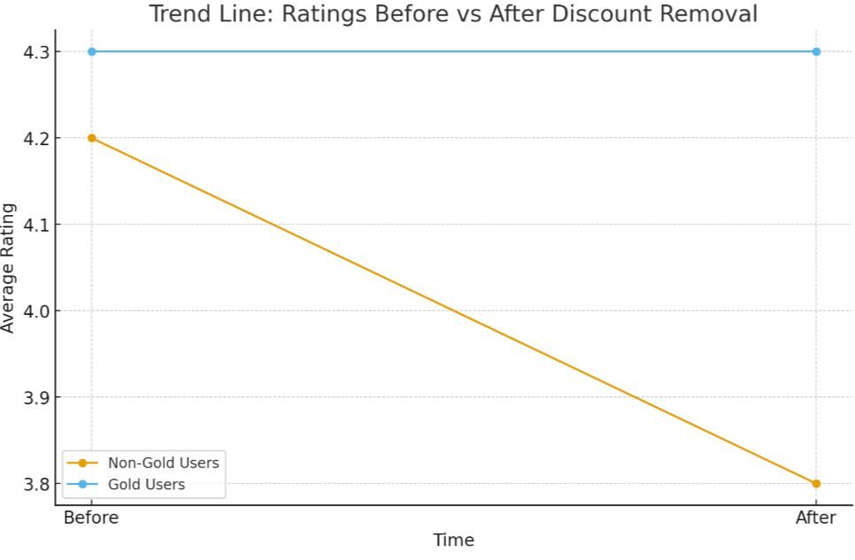  
    
    
  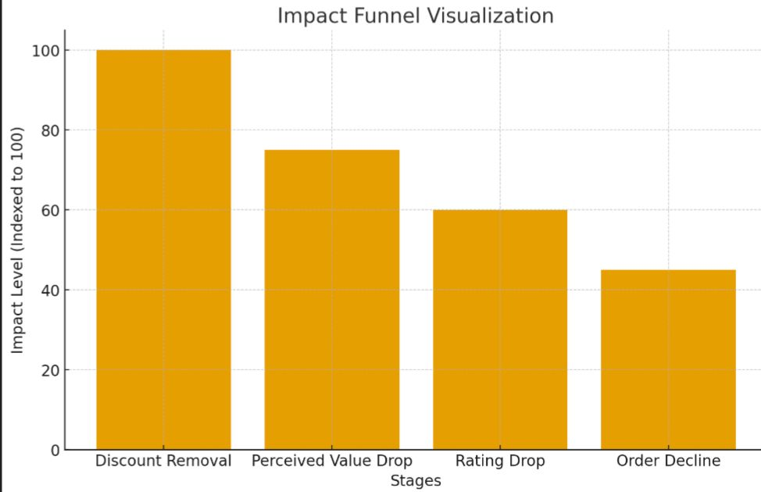  
    
    
   **Related Problem #1**  
   **Decline in Order Volume**
* **Observation:**  
   Monthly delivery orders from non-Gold users in Pune dropped by **15%** post discount withdrawal. The affected audience largely consists of **students and young professionals**, a highly **price-sensitive demographic** that relies heavily on discounts and affordable meal options.
* **Hypothesis:**  
   These users either **switched to local competitors** offering cheaper tiffin or meal plans or **reduced their order frequency** due to a perceived drop in value.

**Solution:**

* **Introduce “Flash Offers” restaurant** funded, time bound deals visible to *all* users (including non-Gold).
* **Display “Value Score”:** An index combining affordability + quality, helping users quickly identify the best-value restaurants.  
    
  **How It’s Calculated (Example Formula)**  
    
   Value Score=(w1 ×Affordability)+(w2 ×Quality)  
    
  **Affordability Index** (0–10): Based on avg. order value vs city median. → Lower prices = higher affordability score.
* **City Median** = the “middle price” of orders in a city. Think of it as a **reference point** to know if a restaurant is cheap, expensive, or average compared to others in the city.
* **Why it matters:** When we show users which restaurants give **best value for money**, we need a standard. We can’t just say “₹230 is cheap” it’s cheap **relative to other restaurants in the city**. That’s why we use the city median.
* **Example:**
* Imagine 5 restaurants in Pune with avg orders: ₹150, ₹200, ₹230, ₹350, ₹400
* Sort them: 150, 200, 230, 350, 400
* The **median** is ₹230 (middle number).
* Now compare each restaurant to this:
* Less than ₹230 → cheaper → high Affordability score
* More than ₹230 → expensive → lower Affordability score

|  |  |
| --- | --- |
| Price < media | High score (6–10) |
| Price = median | Medium score (5) |
| Price > median | low score (1–4) |

* **w₁ = weight for affordability** → how much importance you give to price
* **w₂ = weight for quality** → how much importance you give to quality

**Related Problem #2**   
  **Drop in User Reviews**

**Observation:**  
 Written reviews (detailed feedback) dropped by **25%**, although star ratings were still being given.

**Possible Reasons:**

* Negative experiences discouraging feedback.
* Review prompt fatigue.
* Unengaging feedback interface.

**Solutions:**

* **Gamify reviews:** badges like *Top Reviewer – Pune* or *Food Explorer*.
* Add **emoji-based quick feedback** for delivery experience.
* Send **personalized prompts** (“Help others discover great meals like yours!”).  
    
    
   Monitoring Metrics  
  To ensure sustained recovery, track:
* **Avg. Rating** (Gold vs Non-Gold users)
* **Discount Redemption Rate**
* **Repeat Order Rate**
* **Review Submission Rate**
* **Delivery Time Satisfaction Score**

**Dashboard Setup:**  
 Weekly monitoring of these KPIs for Pune and comparable cities to detect anomalies early.

Conclusion  
  
The **10% decline in Pune’s restaurant ratings** is a multifaceted issue, driven primarily by **pricing sensitivity and competitive dynamics**:

1. **Discount Retraction Impact**
   1. Pune’s user base is **heavily skewed toward students and young professionals**, a segment highly responsive to perceived affordability.
   2. Withdrawal of targeted discounts for non-Gold users altered the **perceived value proposition**, reducing satisfaction even if food quality remained unchanged.
2. **Competitive Pressures**
   1. The proliferation of **low-cost local tiffin services** created alternative options that are attractive to cost-conscious users.
   2. This increased churn among first-time and occasional users, amplifying the rating decline.
3. **Perceived Value Erosion**
   1. Even with consistent quality across restaurants, the **Value Score perception declined**.
   2. Users equate value with **price + quality**, so any shift in pricing without a compensatory communication strategy can impact engagement metrics and ratings.  
        
      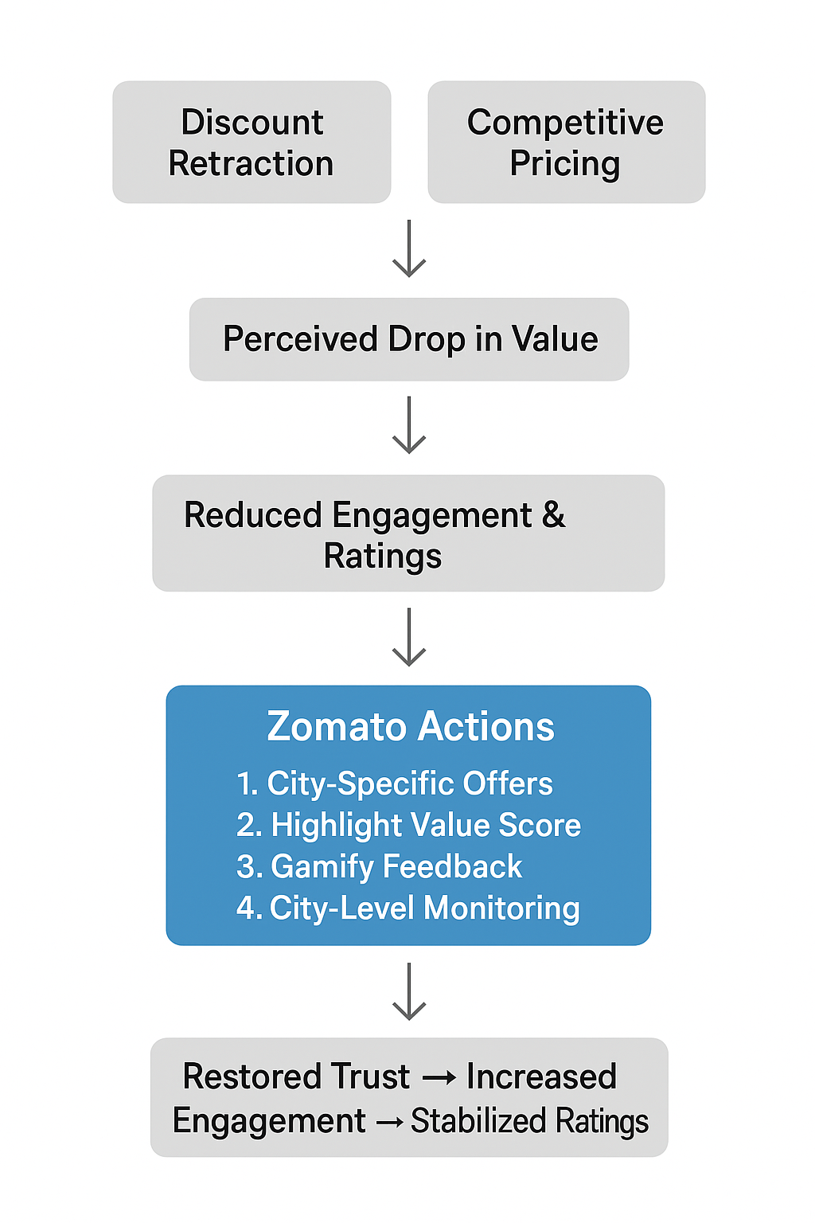  
        
        
        
        
        
        
       End Note   
        
      This is not a ratings problem it’s a perception and loyalty problem. By restoring value equity for non-Gold users and leveraging local competitor intel, Zomato can not only recover ratings but strengthen its defensibility in price sensitive markets like Pune. Every challenge is an opportunity, here’s how we turn a dip in ratings into a leap in growth.